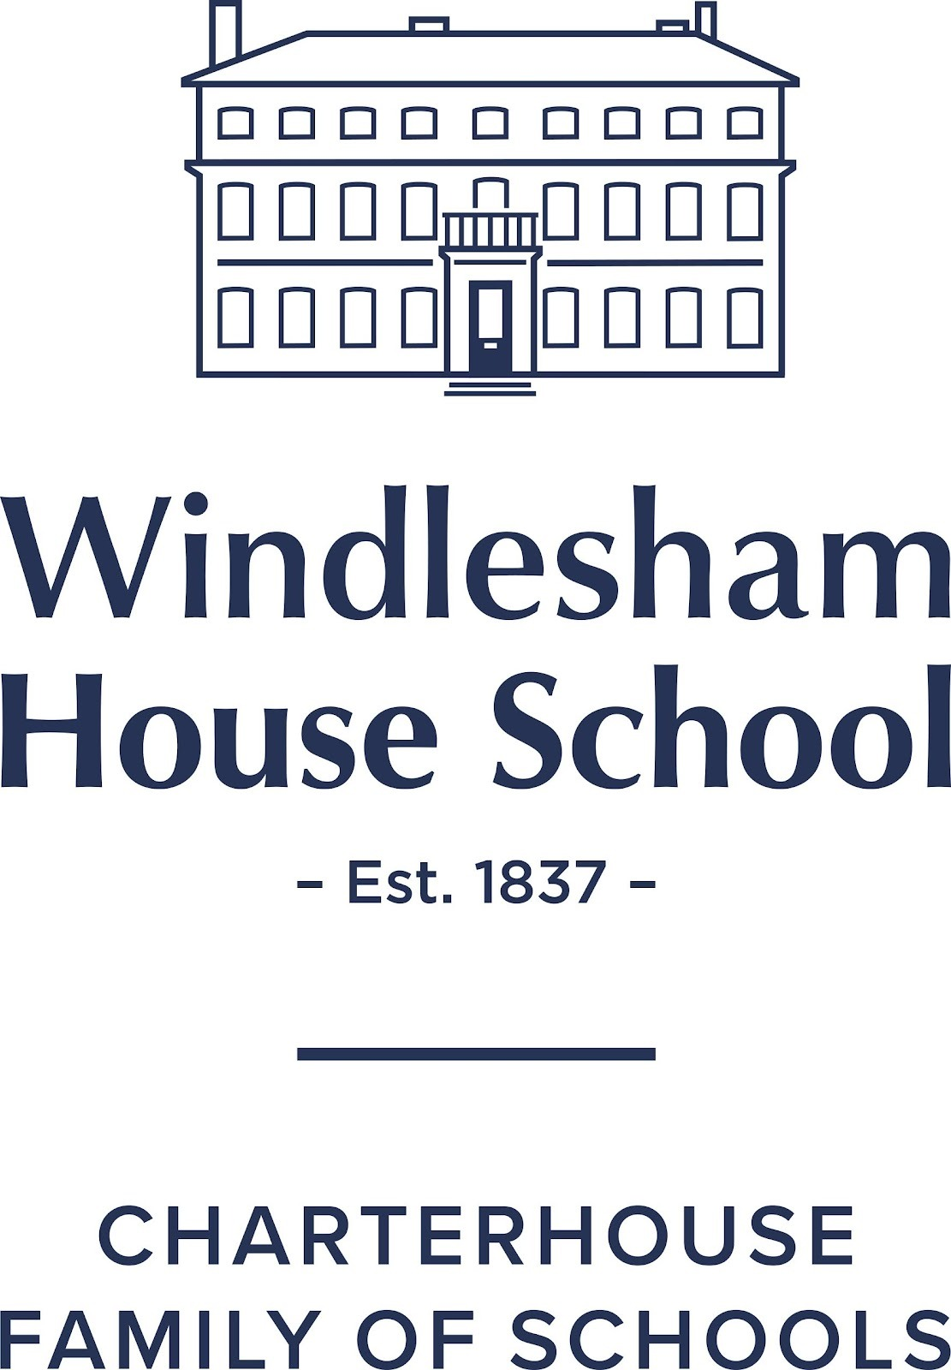
Independent boarding and day school for boys and girls | 4-13 years
Ben Evans | Head

Scholarship Entry Form 2026
Scholarship Day 5 February 2026
Closing date 15 January 2026
Candidate
Surname:
Forenames:
Date of birth:

Please tick which areas the candidate will be assessed for:

Academic
Art & Design
Drama
Computing & Digital
Music  (specify instrument(s)) |  | State instrument
Sport  (specify main sports) |  | State sports

Signed by the parent or guardian

Signed:____________________________________________________________ Date: ____________________

Please return this form, along with a registration form (see here) and the candidate’s last school report by 15 January 2026 to admissions@windlesham.com

